**Project Development Phase**

**Model Performance Test**

|  |  |
| --- | --- |
| Date | 9 November 2023 |
| Team ID | Team-591950 |
| Project Name | Project - Image Caption Generation |
| Maximum Marks | 10 Marks |

**Model Performance Testing:**

Project team shall fill the following information in model performance testing template.

|  |  |  |  |
| --- | --- | --- | --- |
| **S.No.** | **Parameter** | **Values** | **Screenshot** |
|  | Model Summary | Total params: 134260544  Trainable params: 134260544  Non-trainable params: 0 |  |
|  | Accuracy | Training Accuracy - 97.81%  Validation Accuracy – 98.17% |  |
| 3. | Confidence Score (Only Yolo Projects) | Class Detected - NA  Confidence Score - NA | NOT APPLICABLE |

**Model Summary:-**

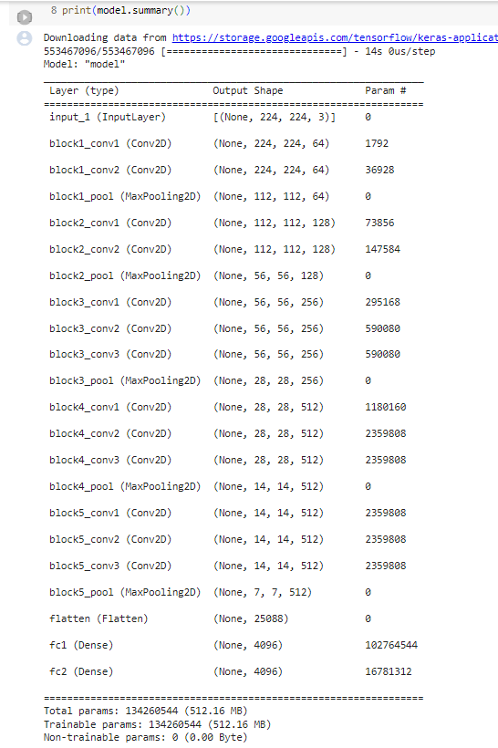

**Accuracy:-**

